A Critique of the 2010 North Carolina Sea-Level Rise Assessment Report

By Dave Burton
Cary, NC
http://www.burtonsys.com/email/
M: 919-244-3316
March 29, 2011 (updated Sept. 28, 2011)
"Future generations will wonder in bemused amazement that the early twenty-first century's developed world went into hysterical panic over a globally averaged temperature increase of a few tenths of a degree and, on the basis of gross exaggerations of highly uncertain computer projections combined into implausible chains of inference, proceeded to contemplate a roll back of the industrial age."
- Dr. Richard Lindzen (Alfred P. Sloan Professor of Meteorology, Department of Earth, Atmospheric and Planetary Sciences, MIT)

Table of Contents

Background 3
Summary 3
Trickle-down Errors 4
The 2010 DCM Assessment and Strategy draft document says 4
The draft NC Coastal Habitat Protection Plan says 4
Problems I found in the Report 5
Claim #1 (p.3): “This report synthesizes the best available science on SLR as it relates specifically to North Carolina.” 5
Claim #2 (p.6): “Sea level is the average height of the sea with respect to a conceptual reference surface called the geoid.” 5
Claim #3 (p.6): “Currently, MSL is rising at a rate of approximately 2mm per year (0.08 inches/yr) if averaged over the last hundred years, and around 3mm per year (0.12 inches/yr) over the last fifteen years. The rate of MSL rise has increased in response to global warming.” 6
Claim #4 (p.6): “SLR can be directly measured in a straightforward way. The longest record of direct measurement of sea level comes from tide gauges.” 10
Claim #5 (p.6): “A drawback to tide gauges in North Carolina, in addition to their small number, is that most of them don’t extend back in time more than 50 years, making it difficult to resolve changes in the rate of rise over the decades.” 10
Claim #6 (p.7): “The 2007 IPCC report estimates that for the period 1961-2003, approximately 60 percent of the SLR was due to an addition of freshwater to the oceans from melting glaciers, while 40 percent was due to thermal expansion. For the period 1993-2003, the ratio reversed, with thermal expansion accounting for 60 percent of the rise.” 11
Claim #7 (p.7): “The IPCC Fourth Assessment Report (IPCC, 2007) contains forecasts for global average SLR ranging from 0.18 meters to 0.59 meters (7 to 23 inches) by the year 2100 AD. … IPCC estimates are conservative because contributions to SLR from melting Greenland and Antarctic ice sheets are uncertain and this uncertainty was not included when calculating estimates…” 11
Claim #8 (p.7): “In summary, there is consensus that the rate of SLR will increase during the 21st century and beyond (IPCC, 2007; CCSP, 2008, 2009).” 12
Claim #9 (p.7): “RSL change will, for most coastal locations, be different from globally predicted MSL changes. It is for this reason that management plans should consider rates of RSL rise specifically pertinent to North Carolina rather than rates from other regions or global averages.” 12
Claim #10 (p.9): Table 1. MSL trends for N.C. water-level stations in mm/year (adapted from Zervas, 2004): 13
Claim #11 (p.10): “Over the course of 90 years (to 2100 A.D.), … local differences [in rate of sea level rise] are likely to be overwhelmed by the global effects of accelerating ice melting and thermal expansion.” 17
Claim #12 (p.10): “A rise of 0.4 meter (15 inches) is considered a minimum, since this is the amount of rise that will occur given a linear projection with zero acceleration.” 17
Claim #13 (p.10): “Various models and observations indicate that accelerated rates of SLR in the future are likely” 17
Claim #14 (p.10): “various investigations indicate a two- to four-fold increase in rates of rise over the last century (Church and White, 2006…” 17
Claim #15 (p.11): “Figure 2. … The most likely scenario for 2100 AD is a rise of 0.4 meter to 1.4 meters (15 inches to 55 inches) above present.” 17
Claim #16 (p.11): “the Science Panel believes that the Rahmstorf method is robust and 1.4 meters a reasonable upper limit for projected rise.” 18
Claim #17 (p. 12): “A one meter (39 inch rise) is considered likely in that it only requires that the linear relationship between temperature and sea level that was noted in the 20th century remains valid for the 21st century” 19
Claim #18/Conclusion (p.12): “the Science Panel recommends that a rise of 1 meter (39 inches) be adopted as the amount of anticipated rise by 2100, for policy development and planning purposes.” 19
Appendix: NC Tide Station data 20
8658120 - Wilmington -- the only GLOSS-LTT station in NC 21
8656483 – Beaufort 22
8652587 - Oregon Inlet Marina 23
8659084 – Southport 24
8651370 – Duck 25
8654400 - Cape Hatteras 26
8656590 - Atlantic Beach 27
8659182 - Yaupon Beach (Oak Island) 28

Background
The Report was prepared by the N.C. Coastal Resources Commission’s (“CRC”) Science Panel on Coastal Hazards (“the Science Panel”) for the N.C. Department of Environment and Natural Resources, Division of Coastal Management (“DCM”).
The key question they attempt to answer is, “how much SLR (sea level rise) the CRC should be planning for by 2100.” (p.3)

Summary
Unfortunately, the Report is riddled with errors. It is strikingly unscientific in its approach, and its conclusion is wildly wrong:
- It began by cherry-picking a single, outlier NC tide station as representative of the State, obviously chosen for its atypically large rate of recorded sea level rise.
- It used just 24 years of sea level data from that tide station, despite the fact that 32 years of data were available, and other NC tide stations had over 75 years of data available.
- It conflated sea level measurements from coastal tide gauges with mid-ocean sea level measurements from satellites, creating the illusion of an increase in rate of sea level rise.
- Then it applied a discredited methodology from a fringe alarmist researcher, to justify predicting a wildly accelerated rate of sea level rise, far beyond even the IPCC’s alarmist predictions.
- Then it exaggerated even his implausible projections.
- Worst of all, it never even mentioned the fact that the actual historical record of sea level has shown no sustained acceleration in rate of rise for over 80 years, neither globally, nor here in North Carolina. That is the single most important thing to know about sea level rise, but you can’t learn it from this Report.
The Report recommends planning for one meter (39 inches) of sea level rise by 2100, for all of North Carolina.
That is absurd. The best science indicates that most of the NC coast will see only 3-14 inches of sea level rise by 2100, though in northeastern NC 12-20 inches is likely due to land subsidence.

Trickle-down Errors

Unfortunately, the erroneous information in this report is corrupting other reports, with great potential to cause misguided public policy decisions. Here are examples of two other reports which have drawn upon this one, uncritically incorporating its erroneous conclusion, and sometimes adding errors of their own. Google finds many others, as well.

The 2010 DCM Assessment and Strategy draft document says
p. 12 (p.14 in Adobe Reader): “For the past 30 years, our policies and strategies have been based on a SLR rate of 1-foot to 1 1/2-feet per century. However, based on the recommendation from the CRC’s Science Panel on Coastal Hazards (March 2010), the NC Coastal Resources Commission has adopted a rise of 1 meter by 2100 for planning purposes. This accounts for an accelerated rise.”
Here you can see the uncritical acceptance of the Report’s wildly exaggerated projection causing misguided policies and strategies.
p. 14 (p.16 in Adobe Reader): “Sea level Rise: Rising sea level is a threat to coastal and riparian wetlands in North Carolina... [Tide] gauge data specific to North Carolina are available only for 20 years, but suggest a... rate of approximately 4.57 mm per year (1.5 ft per 100 years). … Rising sea levels will inundate large areas of the Albemarl-Pamlico Peninsula...”
Here you can also see that the Assessment & Strategy authors assumed (quite reasonably) that if the Science Panel used only 24 years of data (which the A&S authors apparently misread as 20 years) it must be because that’s all the data that was available. You’d think so, wouldn’t you?
In fact, three NC tide stations have more than 50 years of data available, and the GLOSS-LTT tide station at Wilmington has 75.8 years of nearly continuous high quality tide gauge data, which the Science Panel ignored. Wilmington’s sea level has risen at an average rate of only 7.8" per century, with no sign of acceleration, and no rise in sea level at all in the last 20 years.
Additionally, the A&S authors assume that the tide gauge highlighted in the Report is typical for NC. You’d think so, wouldn’t you? Otherwise, why would the Science Panel choose it?
In fact, Duck is an outlier, which records a much higher rate of sea level rise than other NC sites.
pp. 105-106 (107-108 in Adobe Reader): “The Science Panel's report... goes on to recommend that the CRC adopt a rise of one meter by 2100 as a planning level. The report represents a secure foundation upon which the CRC can proceed to pursue program changes... The Science Panel's report is ready to be translated into policy... for changes to the regulatory program.”
In fact, the Report is a very inaccurate, and a terrible basis for policy-making.
Note: the final version of the NC DCM Assessment and Strategy report is now available.

The draft NC Coastal Habitat Protection Plan says
p. v (p. 7 in Adobe Reader): “Completion of several studies indicates that sea level rise is expected to increase in North Carolina at least 1 m per 100 yr.”
Notice how the errors grow in retelling: “1 meter” becomes “at least 1 meter,” and one botched report becomes “several studies.”

Problems I found in the Report

Claim #1 (p.3): “This report synthesizes the best available science on SLR as it relates specifically to North Carolina.”
In fact, it is wildly at variance with the best available science on sea level rise.

Claim #2 (p.6): “Sea level is the average height of the sea with respect to a conceptual reference surface called the geoid.”
First, I should mention a minor issue with terminology.
The terminology used in the Report is slightly unusual. Most commonly, “local mean sea level” or “LMSL” is used to refer to sea level measured at a particular location, but the Report calls this “RSL.” Most commonly, “global mean sea level” or GMSL refers to any of several kinds of global averages of LMSLs, but the Report calls this “MSL” or just “sea level.”
That could cause confusion, because “MSL” is often used to refer to LMSL (which the Report calls RSL). For example, if you download data for a tide station from NOAA’s web site, the local mean sea level is called “MSL.”
In this critique, I’ve used the terms GMSL and LMSL, except within quotes.
A much worse problem is that the definition given on page 6 of the Report is the wrong one. This is not the definition of global mean sea level which has historically been used, nor is it the definition which is useful for coastal planning.
The Science Panel is using a new definition for sea level which is mainly applicable to sea level in the open ocean. But, for coastal planning, it doesn’t matter whether the sea level goes up or down in mid-ocean. All that matters is whether sea level goes up or down at the coasts, which is not the same thing at all.
Until a little over 15 years ago, all measurements of sea level were done at the coasts, by tide gauges. Global mean sea level was estimated by averaging coastal sea level measurements (using various weighting strategies, since we don’t have enough tide gauges to monitor sea level at all the world’s seacoasts). But in 1992 the first satellite was launched which was capable of measuring sea level over the mid-ocean, giving us the ability to measure a new sort of global mean sea level.
It is a fundamental error to use this new definition for coastal planning, because it isn’t a measure of coastal sea level. The two definitions of global mean sea level have different meanings and result in different rates of sea level change.
To understand one of the reasons why this is so, consider what happens when there is a density change in the top layer of seawater in the open ocean (perhaps due to temperature change). If the density decreases (the water expands) then the sea level rises, in place, in the open ocean, without affecting coastal sea levels at all. (Mariners call this concept “displacement” – it is measured in units of mass, not volume.)
Examples of this are icebergs and sea ice. When frozen, water has reduced density, so an iceberg (or Arctic icecap) rises above the surrounding liquid water. Its top surface is a locally elevated sea level. When the ice melts, that locally elevated sea level falls, but it has no effect at all on coastal sea level, because the iceberg’s water has the same mass (displacement) regardless of its varying density and solidity.
The same thing happens when surface water warms in the open ocean. Sea level goes up locally, in the open ocean, due to thermal expansion of the water, but it has no effect at all on coastal sea levels.
(Note: density changes in seawater in lower layers of the ocean do affect coastal sea levels, but it takes hundreds of years for surface heat to find its way down to the lower layers of the ocean, so anthropogenic global warming cannot have much affected it yet.)

Claim #3 (p.6): “Currently, MSL is rising at a rate of approximately 2mm per year (0.08 inches/yr) if averaged over the last hundred years, and around 3mm per year (0.12 inches/yr) over the last fifteen years. The rate of MSL rise has increased in response to global warming.”
That is wrong. Actually, global mean coastal sea level has been rising at only about 1.1 mm/year over the last hundred years or so, and the rate is not accelerating. Only if satellite (non-coastal) sea levels are being discussed, or computer model-based “corrections” added, can such high rates of global mean sea level rise be found.
Sea level is rising, but very slowly. The rise in sea level seems to be in response to warming, in the sense that it commenced at roughly the end of the Little Ice Age (LIA), in the late 1800s. However, it certainly is not due to anthropogenic (human-induced) global warming, because the rate of sea level rise ceased to increase 80+ years ago, which was before most human-produced greenhouse gases were released into the atmosphere. Even the IPCC’s Third Assessment Report (2001) noted the “observational finding of no acceleration in sea level rise during the 20th century.”
The finding of no acceleration in rate of sea level rise was more recently confirmed by Houston & Dean (2011). They wrote in their conclusion, “Our analyses do not indicate acceleration in sea level in U.S. tide gauge records during the 20th century. Instead, for each time period we consider, the records show small decelerations that are consistent with a number of earlier studies of worldwide-gauge records.”
Note #1: Most of the NC coast is slowly subsiding, so NC’s average coastal rate of increase for Local Mean Sea Level (LMSL, which the Report calls “RSL”) is above the global average, and is, coincidentally, a little over 2mm/year. But that’s not what the Science Panel was talking about.
Note #2: There was a paper produced in 2006 by Church & White, which claimed to have detected a slight “20th century acceleration in sea level rise” (while admitting that no previous researchers had found such an acceleration). However, the 20th century acceleration in sea level rise disappeared when they later updated their data (with sea levels through 2007 instead of 2001).
Here’s a graph which I made by applying Church & White’s 2006 paper’s methodology to their more recent sea level data (called “2009” but really just through 2007), for years 1900 and later. As you can see, the acceleration in rate of sea level rise following the end of the LIA had ceased by 1930, and despite all of humanity’s greenhouse gas emissions there’s been no sustained acceleration in global mean sea level rise since then. (The orange line is a minimum-variance unbiased estimator quadratic fit to the data, and the negative quadratic coefficient and slight downward curve indicate deceleration in rate of sea level rise.):
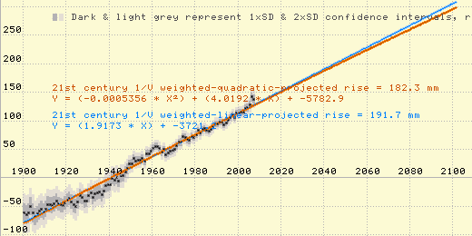Figure 1

A simple average of the sea level trends measured by the 159 GLOSS-LTT tide gauges around the world (which is the very best data we have on coastal sea levels) yields an average rate of sea level rise of only about 0.6 mm/year. (Note: 1/4 of the GLOSS-LTT coastal tide gauges show sea levels falling, rather than rising!) More sophisticated averaging, which takes into account the uneven geographical distribution of the tide gauges, yields a global average mean sea level rise of just over 1.1 mm/year.
The widely bandied about 1.7 - 1.8 mm/year figure for global coastal mean sea level rise over the last century (which the Science Panel has apparently rounded up to 2 mm/year) is the result of “correcting” actual data by adding adjustment factors calculated from computer models. The late John Daly explained it well:
"The impression has been conveyed to the world's public, media, and policymakers, that the sea level rise of 18 cm in the past century is an observed quantity and therefore not open to much dispute. What is not widely known is that this quantity is largely the product of modeling, not observation, and thus very much open to dispute, especially as sea level data in many parts of the world fails to live up to the IPCC claims."

The disparity between the measured rate of sea level rise and the alarmists’ claimed rate is partially due to the computer model-based “corrections” which the alarmists routinely add to measured rates of coastal sea level rise, to account for land movement. Their adjustments “correct” primarily in one direction: up. They correct for Glacial Isostatic Rebound (which, for most locations, increases the reported rate of sea level rise), but they do not correct for land subsidence due to water, oil & gas wells.
AR4 admits this (though without mentioning how it biases the result) in the final paragraph of AR4 section 5.5.2.1 (or here). Unfortunately, the Science Panel seems to have overlooked it. The key sentence is, “Trends in tide gauge records are corrected for GIA using models, but not for other land motions.”
Correcting only for factors that reduce the average rate of sea level rise, and not for factors that increase it, inflates the reported rate of global mean sea level rise.
Actual global mean coastal sea level, as measured by tide gauges, has exhibited no acceleration in the last 80+ years.
So, you might wonder, if global mean sea level rise hasn’t accelerated, and it used to be 1.1 to 1.2 mm/year (“corrected” to 1.7 or 1.8 mm/year), then where does that 3 mm/year claim for the last 15 years come from?
I know of two sources for this error:
1. Confusion about the difference between satellite-measured sea level and coastal sea levels measured by tide gauges. We have just over 15 years of satellite data. The satellites are measuring a higher rate of sea level rise than are the tide gauges (though neither the satellites nor the tide gauges are detecting an acceleration in rate of sea level rise). If you draw a graph that uses tide gauge data until 15 years ago, but then switches to using satellite data, you’ll create an apparent acceleration for the last 15 years.
Equating the two different kinds of sea level measurement is simply wrong, but climate alarmists often do it anyhow, creating an illusion of acceleration in rate of sea level rise. This is explained well by Dr. Willem de Lange, of New Zealand’s University of Waikato, here.
2. Deliberate deception. Some global warming alarmists simply don't care about the truth. Their blatant and intentional manipulation and misinterpretation of data is sometimes just amazing.
Consider NASA’s James Hansen (infamous from Climategate). Hansen’s team is one of the main sources for the claim that the rate of sea level rise has accelerated from 1.7 or 1.8 mm/yr (which is already an exaggeration) to over 3 mm/year.
Let me show you how they try to justify that false claim. Take a look at this slide, from a NASA presentation at a symposium in Fall, 2009:
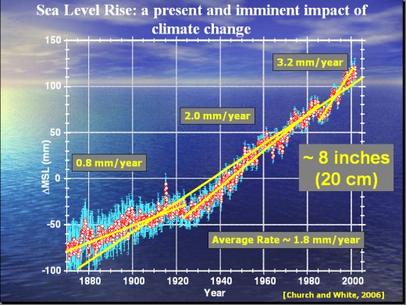Figure 2
On the basis of “23 Annual Tide Gauge Records” the presenter claimed that the rate of sea level rise increased around approximately 1910 (in an earlier slide) or 1925 (in this slide) to 2.0 mm/year, a rate which his first tide gauge line shows holding steady through the end of the 20th century, but which this slide purports to show increasing to 3.2 mm/year around 1985.
Now, look closely at this graph. Do you see the chicanery? They reset the starting points downward for the trend lines! For both the 2.0mm/yr and 3.2 mm/yr line segments, they intentionally skewed the slopes higher by starting with a negative noise spike. Plus, for the 3.2 mm/yr segment they also ended it on a positive noise spike (and had to stop the segment prematurely to find the highest spike)!
That is obvious, shameless, intentional distortion of the data.
Also, why do you suppose that they chose to look at just 23 tide gauges? There are 159 tide gauges in the GLOSS-LTT set, chosen specifically for monitoring long-term sea level trends, because of the quality of their records and their good geographical distribution. 70% of them have recorded local MSL trends of less than NASA's claimed 2.0 mm/yr. 44 of the 159 GLOSS-LTT tide stations have tide records dating from the 1800s, though two ceased operation in the 1930s, leaving 42. Of the 42, 36 (86%) show MSL trends of less than 2.0 mm/yr.
Also, note the credit at the bottom of the NASA graph: “[Church and White, 2006].” That’s the same paper that I mentioned earlier. (Church and White’s newer data shows no 20th century acceleration in sea level rise, after all.)
What’s more, in that same 2006 paper Church & White admit adding a fudge factor which increased the reported rate of global mean sea level rise! Here's the remarkable admission quoted from their paper:
“An additional spatially uniform field is included in the reconstruction to represent changes in GMSL. Omitting this field results in a much smaller rate of GMSL rise...”
That, along with GIA, is apparently why their reported rate of sea level rise was so much greater than the ~1.1 mm/year value which results from geographically weighted averaging of the best actual tide gauge data.
I asked Church & White why they used the adjective “spatially.” Surely, I assumed, since they were reporting acceleration trends, the “additional field” must at least have been temporally uniform. Wrong! I’ve yet to figure out what that “field” is, but Dr. Church told me that it was not temporally uniform!

Claim #4 (p.6): “SLR can be directly measured in a straightforward way. The longest record of direct measurement of sea level comes from tide gauges.”
That’s true for traditional coastal sea levels, but the Science Panel defined Sea Level in a way that can only be measured by satellites. They seem not to have understood the difference.

Claim #5 (p.6): “A drawback to tide gauges in North Carolina, in addition to their small number, is that most of them don’t extend back in time more than 50 years, making it difficult to resolve changes in the rate of rise over the decades.”
Actually, NC has three different tide gauge records which extend back in time more than 50 years: Wilmington, Southport, and Beaufort.
Wilmington has 75.8 years of near-continuous data, Southport 75 years (with gaps), and Beaufort 58 years (with gaps). However, the Science Panel ignored those long records to focus instead on an inferior 24-year tide record from Duck, which they admit is too short to resolve changes in rate of sea level rise. (In fact, even Duck had eight more years of data available, which the Science Panel did not examine.)
So why did they pick Duck? That seems obvious:
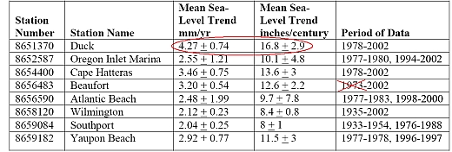Figure 3
(Note that Beaufort actually has data starting in January, 1953, not 1973.)
But could there be another explanation?
I’ve attempted (at least twice) to contact each of the members of the Science Panel, to ask this question (and others). Most haven’t responded, but member one did, and he said that the Science Panel was concerned that dredging near the tide gauges with longer records might have distorted the results, and that one of the reasons they chose Duck was that it was unaffected by dredging.
However, I think that concern is misplaced. From what I've read, channel dredging is usually expected to have only a small effect on mean sea level measurements. It is, however, expected that dredging may sometimes have an effect on the range of tide levels – that is, the mean high water (MHW) minus mean low water (MLW).
So if local MSL was affected by dredging, then MHW-MLW should have been affected even more. Conversely, if there was no noticeable effect on the MHW-MLW from a particular dredging project, then we can be confident that the effect on MSL was inconsequential.
So, I graphed the MHW-MLW for Duck and for the three NC tide stations with long MSL records, over the 1978-2002 period that the Report used, looking for "signals" from dredging. I couldn’t see any. In fact, the two graphs which were most similar were the graphs for Duck and Beaufort.

Claim #6 (p.7): “The 2007 IPCC report estimates that for the period 1961-2003, approximately 60 percent of the SLR was due to an addition of freshwater to the oceans from melting glaciers, while 40 percent was due to thermal expansion. For the period 1993-2003, the ratio reversed, with thermal expansion accounting for 60 percent of the rise.”
That claim is one of the (many) problems in AR4. Note that sea level rise due to thermal expansion of the top layer of the ocean does not affect coastal sea levels. It does affect satellite-measured sea level, but for coastal planning purposes that doesn’t matter.
Only thermal expansion in the lower layers of the ocean affects coastal sea level. Quantifying that is problematic, at present. The Argo Buoys are attempting to measure deep ocean temperatures, but they aren’t finding much warming in the ocean depths. In fact, early reports (now disputed) were that the Argo Buoys were detecting a slight cooling, rather than warming.

Claim #7 (p.7): “The IPCC Fourth Assessment Report (IPCC, 2007) contains forecasts for global average SLR ranging from 0.18 meters to 0.59 meters (7 to 23 inches) by the year 2100 AD. … IPCC estimates are conservative because contributions to SLR from melting Greenland and Antarctic ice sheets are uncertain and this uncertainty was not included when calculating estimates…”
This claim doesn’t even pass the “laugh test!” Anyone who thinks the IPCC’s alarmist predictions are “conservative” hasn’t been paying attention.
Anyone who thinks that the Antarctic ice sheets are in danger of melting really hasn’t been paying attention. As even the IPCC’s 2001 Third Assessment Report noted, “It is now widely agreed that major loss of grounded ice and accelerated sea level rise [from the West Antarctic Ice Sheet] are very unlikely during the 21st century.” (The larger East Antarctic Ice Sheet is the coldest place on earth, and hasn’t melted in millions of years.)
Nor is Greenland a cause for worry. Greenland is colder now than it was in the 1930s and 1940s, and much colder than during the Medieval Warm Period (~800-1100 yrs ago), neither of which saw catastrophic sea level rise from any Greenland ice sheet “tipping point.”[1][2][3][4][5]
The IPCC’s climate alarmism gets diminishing respect in the scientific community, outside of those who have a vested interest in climate alarmism, and it certainly isn’t because they’re too conservative.
Consider, for example, meteorologists. Like climatologists, meteorologists are especially well equipped to distinguish climate from mere weather, and to assess the claims of the IPCC. But, unlike the best-known climatologists, most professional meteorologists have no conflict of interest, because, unlike those climatologists, most meteorologists don’t depend on climate alarmism for their livelihoods. So it is particularly telling that polls of professional meteorologists show that most of them distrust the IPCC and its alarmist conclusions.

Claim #8 (p.7): “In summary, there is consensus that the rate of SLR will increase during the 21st century and beyond (IPCC, 2007; CCSP, 2008, 2009).”
That’s complete nonsense. After over half a century of accelerating greenhouse gas emissions, there has been no acceleration at all in the rate of sea level rise. It is irrational to expect that sea level will suddenly start rising at an accelerated rate in the next 80 years, when it hasn’t done so in the last 80.
In fact, there’s no consensus that significant anthropogenic global warming is occurring, either. Anyone who thinks that there is obviously hasn’t read the U.S. Senate Minority Report, or leading experts like Dr. Fred Singer and Dr. Richard S. Lindzen, or even the BBC.
Famed aviation engineer Burt Rutan has an excellent presentation which can bring you up to speed on the issue fast.
Harris polled 500 leading American Meteorological and Geophysical scientists in early 2007, and even back then, before Climategate, there was no consensus. Harris found that:
"97% agree that 'global average temperatures have increased' during the past century. But not everyone attributes that rise to human activity. A slight majority (52%) believe this warming was human-induced, 30% see it as the result of natural temperature fluctuations and the rest are unsure."
52%-to-30% was obviously no “consensus.” Since then, Climategate has revealed that leading IPCC-associated climatologists were manipulating & withholding data, hiding evidence, and blackballing skeptics to promote anthropogenic global warming alarmism, so there has almost certainly been a further weakening of trust among leading scientists for the IPCC’s conclusions. (The recent series of progressively harsher winters has probably cut into support for global warming theories, as well.)
Even so, the weak and disputed evidence for significant anthropogenic global warming is at least stronger than the completely nonexistent evidence for anthropogenically-triggered catastrophic sea level rise.

Claim #9 (p.7): “RSL change will, for most coastal locations, be different from globally predicted MSL changes. It is for this reason that management plans should consider rates of RSL rise specifically pertinent to North Carolina rather than rates from other regions or global averages.”
That is correct, but we have over 75 years of good tide gauge records for the NC coast (at Wilmington), and by comparison with other locations which have even longer tide gauge records we can extrapolate back further, with much greater confidence than by using questionable “proxies” from sediment deposits.

Claim #10 (p.9): Table 1. MSL trends for N.C. water-level stations in mm/year (adapted from Zervas, 2004):
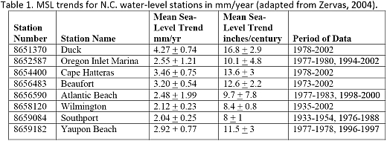Figure 4
That table is very strange.
The newest data in that table is from 2002! But current (February 2011) data from the best NC tide stations is already online at noaa.gov. So why does this 2010 report rely on such severely outdated data?
At the end of this critique, I’ve reported and graphed the latest data and LMSL trend calculations for those eight tide stations.
The best data is from Wilmington: 75.8 years of nearly continuous measurements, starting in 1935. Southport’s data starts in 1933, but has gaps in the measurement record. Beaufort’s data starts in 1953 (not 1973 – the table is wrong).
The other NC tide gauge records are much shorter, and some of those eight tide stations have so little data that to purport to extract trends from them is foolishness. Consider Yaupon Beach (Oak Island), which the table reports as having “2.92 + 0.77” (probably a typo for “2.92 ± 0.77”) rise. The Yaupon Beach tide gauge has only 27 months of LMSL data, compared to 883 months of LMSL data for Wilmington.
Compare NOAA’s graphs for the two locations:
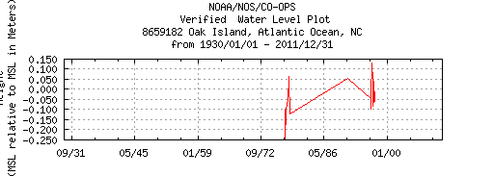Figure 5
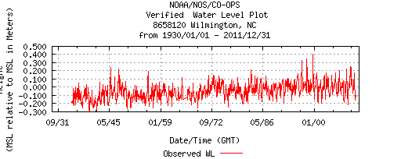Figure 6
The report speaks approvingly of averaging data from multiple NC tide stations, which makes me wonder why anyone would adulterate real, solid data (from Wilmington) by combining it with randomness (from Yaupon Beach, Oak Island)?
And why would they ignore the most recent 8 years of measurements?
The problem for the alarmists is that Wilmington’s tide station (like nearly all other long term tide stations) has seen no sustained acceleration in rate of sea level rise over its 75.8-year history. In fact, Wilmington has seen no sea level rise at all in the last 20 years. But if you delete the last decade of data, you can see what appeared to have been a slight upward trend, in the late 20th century.
With the latest data included, it is clear that the uptick was a transient change, like many other upticks and downticks before it, but it is understandable that it could be mistaken for a trend if (like the Science Panel) you didn’t bother to examine recent data.
Here’s my plot of the last 20 years of Wilmington sea level data, with regression analysis:
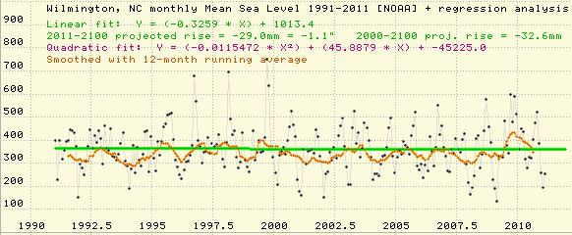Figure 7

Here’s my plot of all the Wilmington sea level data, 1933-2011, with linear and quadratic trend lines fitted by regression analysis, and extrapolated to 2100:
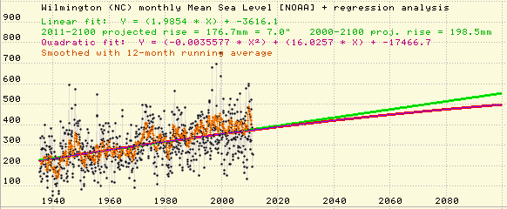Figure 8
That graph represents 75.8 years of the best available NC tide gauge data, from the only GLOSS-LTT tide station in NC. The projections are from regression analysis of the real data. The linear projection is for just 7 inches of sea level rise by 2100. (The quadratic fit shows slight deceleration, so the quadratic projection is even lower, but the deceleration is statistically insignificant so I don’t recommend using the quadratic projection for predictive purposes.)
Contrast that with “Figure 2” of the NC 2010 SLR AR, which is based on just 24 years of data from Duck, a cherry-picked, non-GLOSS-LTT tide station, obviously chosen, in part, because it records the highest rate of LMSL rise in NC. Except for the green linear extrapolation line, the graph’s extrapolations have nothing to do with the data being extrapolated! NC’s actual tide gauge record shows no sign of sustained acceleration in rate of sea level rise. But the Science Panel’s Report predicts massive acceleration anyhow:
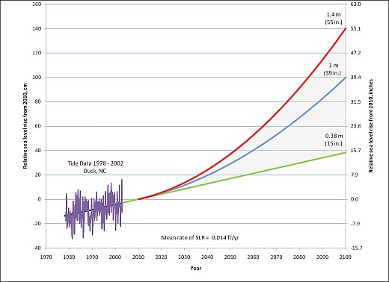Figure 9

Here’s my plot of the sea level data from Duck, with linear and quadratic projections derived by regression analysis of the data:
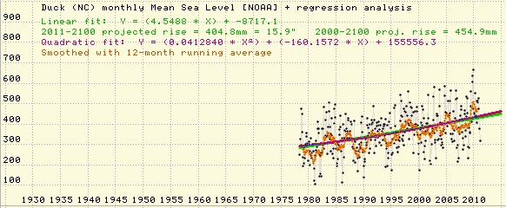Figure 10
The slight upward curve for the quadratic curve indicates a slight acceleration in rate of sea level rise over the period 1978-2011, but (like the slight deceleration at Wilmington) it is statistically insignificant.

Claim #11 (p.10): “Over the course of 90 years (to 2100 A.D.), … local differences [in rate of sea level rise] are likely to be overwhelmed by the global effects of accelerating ice melting and thermal expansion.”
That is completely wrong. Historically, on average, about half of the sea level change seen at coastal tide gauges has been due to local effects, rather than global effects. Even a doubling of the global average rate of sea level rise (from 1.1 mm/yr to 2.2 mm/yr) would result in only about a 50% increase in the long term average rate of local sea level rise at Wilmington, and a 24% increase at Duck.
There is no reason to expect this to change, either. There’s no evidence to support the prediction that ice melting and thermal expansion will accelerate or cause any acceleration in rate of sea level rise over the next 89 years.

Claim #12 (p.10): “A rise of 0.4 meter (15 inches) is considered a minimum, since this is the amount of rise that will occur given a linear projection with zero acceleration.”
That’s complete nonsense. Even a doubling of the global average rate of mean sea level rise (from the current 1.1 mm/yr to 2.2 mm/yr) would result in only a total of 11 inches of rise in sea level by 2100 at Wilmington, and 20 inches at Duck.

Claim #13 (p.10): “Various models and observations indicate that accelerated rates of SLR in the future are likely”
Untrue. Only models support that prediction. The observational data contradicts it.

Claim #14 (p.10): “various investigations indicate a two- to four-fold increase in rates of rise over the last century (Church and White, 2006…”
As I mentioned previously, Church and White’s later (2009) data shows that there was no acceleration in global average mean coastal sea level during the 20th century, and even their earlier data showed that most of the detectable historical acceleration in sea level rise occurred in the 19th century, and all of it occurred before 1930.
There has been no sustained increase in rate of sea level rise during the last 80 years.

Claim #15 (p.11): “Figure 2. … The most likely scenario for 2100 AD is a rise of 0.4 meter to 1.4 meters (15 inches to 55 inches) above present.”
That’s complete nonsense. The most likely scenario for 2100 AD is a global average rise in coastal mean sea level of 0-200 mm (0-8 inches) relative to 2011.
Locations which have higher than typical rates of local mean sea level rise due to local land subsidence can expect a somewhat greater sea level increases. E.g., Wilmington can expect 80-280 mm (3-11 inches), and Duck can expect 300-500 mm (12-20 inches).

Claim #16 (p.11): “the Science Panel believes that the Rahmstorf method is robust and 1.4 meters a reasonable upper limit for projected rise.”
This is very, very wrong.
The “Rahmstorf method” is an ad hoc heuristic described in a 2007 paper by Stefan Rahmstof. It claims to predict rate of sea level rise as a linear multiple of predicted surface air temperature level, relative to an arbitrary point in history. It doesn’t even pretend to be derived from analysis of any physical mechanism that could cause such a relationship, and it is contradicted by the historical record.
According the Rahmstorf method, the rate of sea level rise is directly proportional to the temperature level.
But there has been no acceleration at all in the rate of coastal sea level rise for at least 80 years, neither here in NC nor elsewhere in the world (a period of time which, BTW, includes the vast majority of anthropogenic greenhouse gas emissions). That means one of two possible conclusions is inescapable:
- Either global average temperature has not risen, in which case not merely the whole AGW theory comes crashing down, but also the surface temperature measurement record, and the Report's prediction with them; or,
- Rahmstorf is all wet, in which case the Report's prediction is still baseless.
Global average surface temperatures peaked around 1998, and have plateaued since then, but remain near that high. (By most accounts, 2010 was one of the 3 or 4 hottest years on record, despite ending with a particularly harsh winter.) So, if temperatures increased, why didn't the rate of sea level rise also increase?
According to the Rahmstorf method, the rate of coastal sea level rise should be much higher now than it was during, for example, the chilly 1950s - 1970s.
But look at that Wilmington sea level graph, from NOAA, above. (Or look at any other good quality long-term sea level graph.)
You can easily see that the rate of coastal sea level rise during the (hot) last 30 years was no higher than during the previous (cold) 30 years. Obviously, Rahmstorf’s method doesn’t work.
What’s more, the Rahmstorf method depends entirely on some other source for temperature predictions, and both Rahmstorf and the Science Panel credulously use the IPCC as their source for those predictions.
Now think about that.
Rahmstorf’s method depends on the temperature predictions of the IPCC – yet he (and the Science Panel) rejected the IPCC’s predictions about sea level. If you believe in the “best science” claims of the IPCC, then how can you simultaneously disbelieve their claims about sea level?
For Rahmstorf to be right, the IPCC must be wrong about sea level, but it must also be right about temperature.
And, as if that weren’t enough, the Report exaggerated even Rahmstorf's prediction, because his prediction was actually for a 110-year period, but the Science Panel used it for a 90-year prediction.
The Report called the Rahmstorf method “robust.” But when confronted with criticism of his paper, Rahmstorf eventually admitted (on RealClimate) that his method was flawed. He wrote:
"In hindsight, the averaging period of 11 years that we used in the 2007 Science paper was too short to determine a robust climate trend. The 2-sigma error of an 11-year trend is about +/- 0.2ºC, i.e. as large as the trend itself. Therefore, an 11-year trend is still strongly affected by interannual variability (i.e. weather)"
The Science Panel could have read about Rahmstorf’s mea culpa, and much more about what’s wrong with his method, back in mid-2009, if they’d bothered to.
(You can read much more about the Rahmstorf Method here: http://tinyurl.com/rahmstuff)
So, the Science Panel’s claim is:
- an exaggeration of…
- the result of applying a falsified ad hoc extrapolation method to…
- highly dubious temperature predictions.
It’s hard to imagine how a less trustworthy claim could be derived!

Claim #17 (p. 12): “A one meter (39 inch rise) is considered likely in that it only requires that the linear relationship between temperature and sea level that was noted in the 20th century remains valid for the 21st century”
That claim (misquoted without attribution from an erroneous assertion in the second-to-last paragraph of Rahmstorf’s paper) is pure nonsense. Apparently the Science Panel understood neither Rahmstorf’s method nor the historical record of sea level rise.
In the first place, Rahmstorf didn’t claim to have found “a linear relationship between temperature and sea level.” He claimed that there’s a linear relationship between temperature level and rate of sea level rise (i.e., the first derivative).
In the second place, it is absurd to claim that the prediction “only requires” that Rahmstorf’s method be correct. The prediction is also completely dependent on the accuracy of the IPCC’s dubious global temperature predictions.
(What’s more, according to Rahmstorf’s method, if temperature does not go up then the rate of sea level rise won’t go up either – and, as everyone paying attention knows, global temperatures have plateaued.)

Claim #18/Conclusion (p.12): “the Science Panel recommends that a rise of 1 meter (39 inches) be adopted as the amount of anticipated rise by 2100, for policy development and planning purposes.”
That recommendation is contrary to the best scientific evidence. 7-10 inches is more likely, for most of the North Carolina coast.

Appendix: NC Tide Station data

NOAA lists four tide stations in NC with sufficient quantity and quality of sea level data to calculate meaningful local mean sea level trends: Wilmington, Beaufort, Oregon Inlet Marina, and Southport:
http://tidesandcurrents.noaa.gov/sltrends/sltrends_states.shtml?region=nc

All four of them have sea level data available on NOAA’s web site which is much more recent than the data used in the 2010 NC SLR Assessment Report. (Some of the older Southport & Beaufort data is not available on NOAA’s web site, but at my request they sent it to me, and I’ve put copies of the files on my web site.)

Wilmington has by far the best data: a nearly continuous 75.8-year history of local mean sea level (LMSL), from May 1935 to February 2011.

NOAA calculated rates of sea level rise by regression analysis for those four NC tides stations, using data through 2006. I’ve recalculated the rates of sea level rise using the latest data (through February 2011 except for Southport, which seems to have ceased operation in 2008).

The four other NC tide stations in the Report’s “Table 1” also have downloadable sea level data on NOAA’s web site: Duck, Atlantic Beach, Cape Hatteras, and Yaupon Beach / Oak Island. The data from these tide gauges does not approach the quality of Wilmington’s data, which is presumably why NOAA did not calculate rates of sea level rise for them, but I did the calculations anyhow.

In addition, I fit quadratics to the latest data from all eight tide stations, looking for signs of acceleration in rate of sea level rise. Three of the eight tide stations showed a slight acceleration in rate of sea level rise. The other five tide stations showed slight deceleration in rate of sea level rise. In no case was the acceleration or deceleration statistically significant. Wilmington (with by far the best data) measured a very slight deceleration in rate of sea level rise, so slight that it is barely visible when graphed.

Only Wilmington is a GLOSS-LTT designated station for monitoring long-term sea level trends. It has much more sea level data available than does any other NC tide station.

I downloaded the latest data from NOAA's web site for each tide station, and analyzed it. (For Beaufort and Southport, the data on NOAA’s web site is incomplete, but at my request NOAA sent me the missing data.)

For each tide station, I calculated both linear and quadratic regressions. The small red graphs are downloaded from NOAA’s web site, at the URLs given. The larger graphs are mine, with the monthly and smoothed data, and trend line/curve plots.

8658120 - Wilmington -- the only GLOSS-LTT station in NC

http://tidesandcurrents.noaa.gov/sltrends/sltrends_station.shtml?stnid=8658120
http://tidesandcurrents.noaa.gov/data_menu.shtml?type=Historic+Tide+Data&mstn=8658120&bdate=19300101&edate=20111231&datum=4&wl_sensor_hist=W5&format=View+Plot&data_type=wl&unit=0

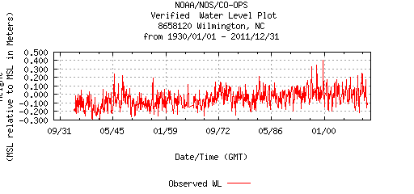Figure 11
Data from 1935 to 2011, 97% continuous. (76-year record, 883 monthly average data points.)
NOAA-calculated trend (based on data through 2006): 2.07 +/- 0.40 mm/yr
Using the latest data, I calculated a trend of 1.99 mm/yr (7.0 inches by 2100).
Fitting a quadratic, I found a very slight (statistically insignificant) deceleration in rate of sea level rise (though, as previously noted, there has been no sea level rise at all in Wilmington in the last 20 years).

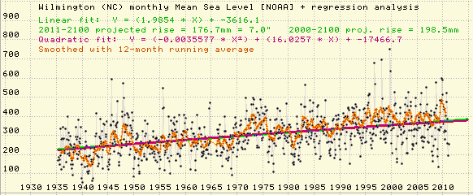Figure 12

8656483 – Beaufort

http://tidesandcurrents.noaa.gov/sltrends/sltrends_station.shtml?stnid=8656483
http://tidesandcurrents.noaa.gov/data_menu.shtml?type=Historic+Tide+Data&mstn=8656483&bdate=19300101&edate=20111231&datum=4&wl_sensor_hist=W5&format=View+Plot&data_type=wl&unit=0

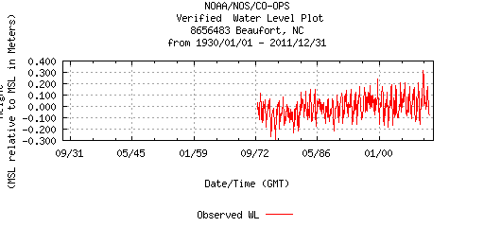Figure 13

*** The 1953-68 data is missing from NOAA's web site, but at my request they sent it to me
(58-year record, 605 monthly data points; the data from 1973 to 2011 is 100% continuous.)
NOAA-calculated trend (based on 1953-2006 data): 2.57 +/- 0.44 mm/yr
Using the latest data, I calculated a trend of 2.67 mm/yr (9.4 inches by 2100).
Fitting a quadratic, I found a slight (statistically insignificant) acceleration in rate of sea level.

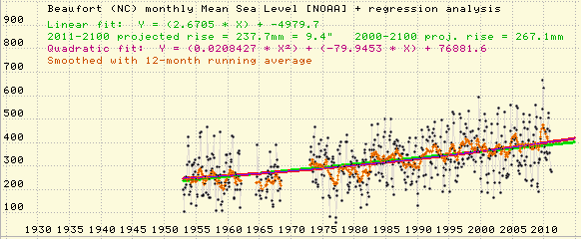Figure 14

8652587 - Oregon Inlet Marina

http://tidesandcurrents.noaa.gov/sltrends/sltrends_station.shtml?stnid=8652587
http://tidesandcurrents.noaa.gov/data_menu.shtml?type=Historic+Tide+Data&mstn=8652587&bdate=19300101&edate=20111231&datum=4&wl_sensor_hist=W5&format=View+Plot&data_type=wl&unit=0

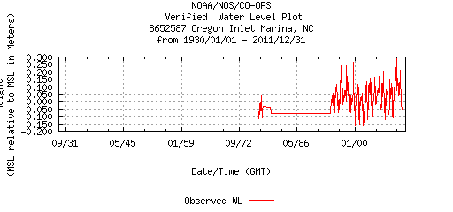Figure 15
Data from 1977-2011, with a 14-year gap, 53% continuous.
(34-year span, with about 18 years of actual data, 217 monthly data points.)
NOAA-calculated trend (based on data through 2006): 2.82 +/- 1.76 mm/yr
Using the latest data, I calculated a trend of 2.87 mm/yr (10.1 inches by 2100).
Fitting a quadratic, I found a slight (statistically insignificant) acceleration in rate of sea level.

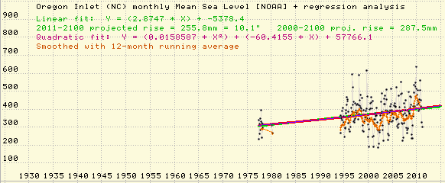Figure 16

8659084 – Southport

http://tidesandcurrents.noaa.gov/sltrends/sltrends_station.shtml?stnid=8659084
http://tidesandcurrents.noaa.gov/data_menu.shtml?type=Historic+Tide+Data&mstn=8659084&bdate=19300101&edate=20111231&datum=4&wl_sensor_hist=W5&format=View+Plot&data_type=wl&unit=0

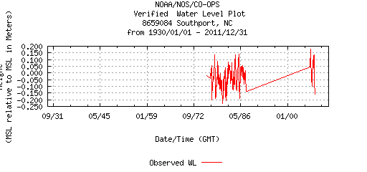Figure 17
*** The 1933-54 data is missing from NOAA's web site, but at my request they sent it to me
Data is present from 1933 to 2008, with two long gaps, 43% continuous.
(75-year span, with about 34 years of actual data, 407 monthly data points.)
NOAA-calculated trend (based 1933-2006 data): 2.08 +/- 0.46 mm/yr.
Using the latest data I calculated an identical trend of 2.08 mm/yr (7.3 inches by 2100).
Fitting a quadratic, I found a slight (statistically insignificant) deceleration in rate of sea level rise.

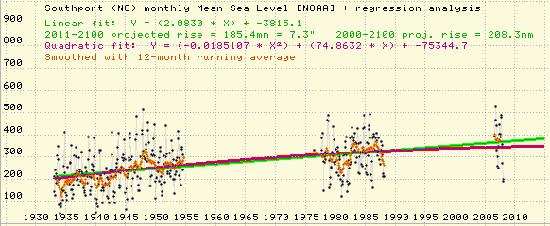Figure 18

NOAA didn't calculate trends for the other four tide stations, but they do have data for them. None go back further than 1978, and only Duck has any recent data.

8651370 – Duck

http://tidesandcurrents.noaa.gov/data_menu.shtml?type=Historic+Tide+Data&mstn=8651370&bdate=19300101&edate=20111231&datum=4&wl_sensor_hist=W5&format=View+Plot&data_type=wl&unit=0

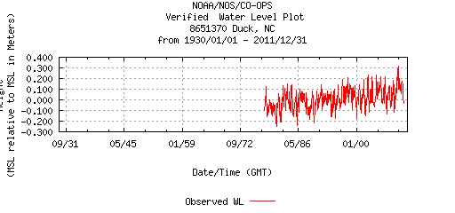Figure 19
394 monthly data points (1978-2011), a 32.5-year span.
NOAA didn’t calculate a trend, but NC 2010 SLR AR / Zervas (2004) says rate was 4.27 +/- 0.74 mm/yr for 1978-2002.
Using the latest data, I calculated a trend of 4.55 mm/yr (15.9 inches by 2100).
Fitting a quadratic, I found a slight (statistically insignificant) acceleration in rate of sea level rise.

Figure 20

8654400 - Cape Hatteras

http://tidesandcurrents.noaa.gov/data_menu.shtml?type=Historic+Tide+Data&mstn=8654400&bdate=19300101&edate=20111231&datum=4&wl_sensor_hist=W5&format=View+Plot&data_type=wl&unit=0

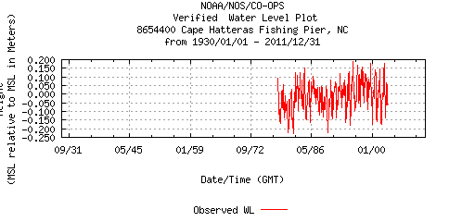Figure 21

299 monthly data points from 1978 to 2003, a 25-year span. This station is apparently no longer in operation.
NOAA didn’t calculate a trend, but NC 2010 SLR AR / Zervas (2004) says rate was 3.46 +/- 0.75 for 1978-2002.
Using all available data, I calculated a trend of 3.30 mm/yr (11.6 inches by 2100).
Fitting a quadratic, I found a slight (statistically insignificant) deceleration in rate of sea level rise.

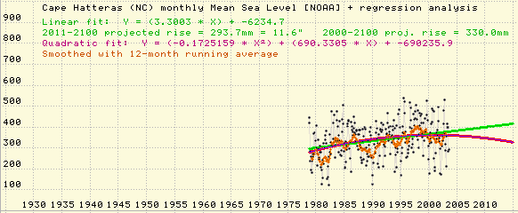Figure 22

8656590 - Atlantic Beach

http://tidesandcurrents.noaa.gov/data_menu.shtml?type=Historic+Tide+Data&mstn=8656590&bdate=19300101&edate=20111231&datum=4&wl_sensor_hist=W5&format=View+Plot&data_type=wl&unit=0

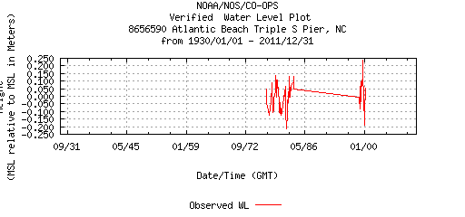Figure 23

71 monthly data points (1977-2000). This station is apparently no longer in operation.
NOAA didn’t calculate a trend, but NC 2010 SLR AR / Zervas (2004) said the rate was 2.48 +/- 1.99 mm/yr for 1977-1983 & 1998-2000.
I calculated a trend of only 1.85 mm/yr (6.5 inches by 2100).
Fitting a quadratic, I found a slight (statistically insignificant) deceleration in rate of sea level rise.

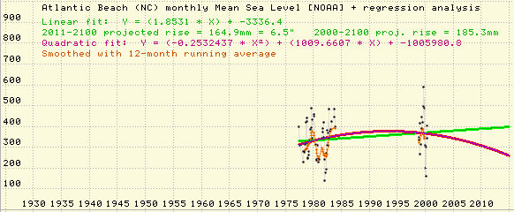Figure 24

8659182 - Yaupon Beach (Oak Island)

http://tidesandcurrents.noaa.gov/data_menu.shtml?type=Historic+Tide+Data&mstn=8659182&bdate=19300101&edate=20111231&datum=4&wl_sensor_hist=W5&format=View+Plot&data_type=wl&unit=0

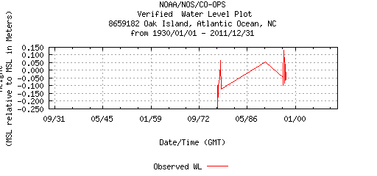Figure 25
26 monthly data points (1977-1997). This station is apparently no longer in operation.
NOAA didn’t calculate a trend, but NC 2010 SLR AR / Zervas (2004) said the rate was 2.92 + 0.77 mm/yr for 1977-1978 & 1996-1997.
I calculated a trend of 3.17 mm/yr (11.1 inches by 2100).
Fitting a quadratic, I found a slight (statistically insignificant) deceleration in rate of sea level rise.

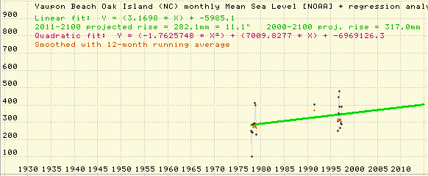Figure 26

